SIMATS ENGINEERING

CSA15 – CLOUD COMPUTING AND BIG DATA ANALYTICS

ASSIGNMENT 3 – CO3
OBE-Based Evidence Principle

Design a Cloud-Based Collaborative Solution
CO3: Implement cloud-based solutions using cloud storage, web APIs, and platform services for real-world applications.

Field | Details | Field | Details
Student Name | M. Srilakshmi | Register Number | 192525404
Department / Section | Btech AIML | Academic Year / Semester | 2nd
Faculty Name | Dr. R. Latha | Nature of Assignment | Individual
Duration | 1 Week | Total Marks | 50
Submission Date | 05/11/2026 | Evaluation Date

MARK SHEET (Rubric-based evaluation)
Task | Title | Max | Awarded | Evidence / evaluation focus
1 | Accessing Cloud Services through Different Methods | 6 |  | Access-method diagram; demonstration; screenshots; comparison
2 | Cloud Platforms and Web Applications | 7 |  | Two platforms; interaction diagram; app demonstration; evaluation
3 | Web APIs for Cloud Access | 7 |  | API design; executable client; two requests; responses
4 | Cloud Security and Network Access | 7 |  | Secure-access architecture; threats; authentication; mitigations
5 | Collaboration Using Cloud-Based Services | 6 |  | Shared workspace; permissions; edits; contribution evidence
6 | Integrated Cloud Access and Collaboration Mini Investigation | 7 |  | Scenario; architecture; prototype; two user tests; evaluation
7 | Day-4 Design Challenge: Cloud-Based Collaborative Solution | 10 |  | Two independent proposals; comparison; joint design; validation; defence
 | TOTAL | 50 |  | Percentage:

OVERALL REMARKS

M. Srilakshmi  Student Signature | _______________  Faculty Signature | _______________  Program Director

MANDATORY SUBMISSION EVIDENCE CHECK

✓ = Present in documented answer; P = Partly present; ✗ = Missing / not satisfied
Task | Evidence expected | Status | Evaluator note
1 | Three access methods, client–network–cloud diagram, demonstration and observations |  | Access-method classification and practical access screenshots to be checked.
2 | Two-platform comparison, interaction diagram and cloud web-app demonstration |  | Platform mapping, user-action sequence and local-versus-cloud evaluation to be checked.
3 | API flow, program, two request inputs, responses and execution evidence |  | Code, actual request/response outputs and analysis to be checked.
4 | Secure-access flow, four security considerations, threat and mitigation analysis |  | Authentication, authorization and secure-communication evidence to be checked.
5 | Shared workspace, permission settings, two collaborative activities and contributions |  | Verify shared editing, user roles, permissions and contribution screenshots.
6 | Integrated scenario, architecture, prototype, two user scenarios and results |  | Verify cloud access, collaboration workflow, tests and limitations.
7 | Two initial proposals, comparison record, joint design, tests and cross-defence |  | Verify independent proposals, joint decisions, observed results and both students’ understanding.

IMPLEMENTATION EVIDENCE CHAIN
Evidence item | Status | Observation
Cloud access methods |  | Browser, mobile and API access methods explained.
Cloud platforms |  | Two cloud platforms and their applications compared.
Cloud access demonstration |  | Actual screenshots need verification.
Web API implementation |  | Program and execution outputs need verification.
Cloud security |  | Authentication, authorization and security measures explained.
Cloud collaboration |  | Shared workspace and editing evidence need verification.
Mini-project |  | Design included; practical testing needs verification.
Day-4 design challenge |  | Individual proposals, joint design and validation need verification.
Student contributions |  | Contributions of both students need confirmation.
Screenshots |  | Original execution screenshots required.

SUBMISSION CHECKLIST (Not Separately Marked)
Requirement | Status
All 7 questions answered | ☐ Yes ☐ Partly ☐ No
Cloud access methods explained | ☐ Yes ☐ Partly ☐ No
Cloud architecture diagrams included | ☐ Yes ☐ Partly ☐ No
Two cloud platforms compared | ☐ Yes ☐ Partly ☐ No
Web API program and testing completed | ☐ Yes ☐ Partly ☐ No
Cloud security explained | ☐ Yes ☐ Partly ☐ No
Cloud collaboration demonstrated | ☐ Yes ☐ Partly ☐ No
Mini-project completed and tested | ☐ Yes ☐ Partly ☐ No
Day-4 design challenge completed | ☐ Yes ☐ Partly ☐ No
Student A and B contributions recorded | ☐ Yes ☐ Partly ☐ No
Screenshots and practical evidence attached | ☐ Yes ☐ Partly ☐ No
Viva recommended | ☐ Yes ☐ No

CLOUD COMPUTING AND BIG DATA ANALYTICS
ASSIGNMENT 3 – CO3

CO3: Implement cloud-based solutions using cloud storage, web APIs, and platform services for real-world applications.

Mode: Pair Work – 2 Students per Group
Duration: 1 Week Total Marks: 50

OBE-Based Evidence Principle

The assignment requires students to demonstrate measurable evidence of:
Understand → Design → Implement → Demonstrate → Analyse → Evaluate
Both students must understand the complete assignment. Students should not simply divide questions between them. Individual responsibilities are assigned within each question so that the contribution and attainment of CO3 can be independently verified.

Q1 – Accessing Cloud Services through Different Methods 6 Marks
Shared Group Work
Together, the pair must:
- Identify different methods of accessing cloud services.
- Study browser-based/cloud console access.
- Study access through mobile applications.
- Study access through APIs.
- Identify the role of Internet/network connectivity.
- Select one suitable cloud service for demonstration.
Student A – Access Method Design
Student A must individually:
- Identify and classify at least three cloud access methods.
- Prepare a simple architecture/flow diagram showing:
Client → Network → Cloud Service
- Explain how a user accesses the selected cloud service.
- Identify the hardware/software requirements.
- Explain the role of the client and network.
- Justify which access method is most suitable for the selected application.
Student B – Practical Evidence
Student B must individually:
- Demonstrate access to a cloud service using one selected method.
- Record the steps/screenshots as evidence.
- Test the access using different devices or access methods where possible.
- Record observations such as accessibility, response, and usability.
- Identify one limitation encountered during access.
- Explain how the limitation can affect cloud usage.
Cross-Verification
Student A must be able to explain Student B's practical demonstration.
Student B must be able to explain Student A's access architecture.
Evidence Expected: Architecture diagram + screenshots/observations + comparison.

Q1. Accessing Cloud Services through Different Methods (6 Marks)

Shared Group Work
A cloud service is not tied to one screen or one gadget. It sits in a remote data centre, and the user reaches it through whichever doorway suits the moment. Three doorways were studied by the pair:
- Browser or cloud console: the service is opened as a web page. Nothing needs to be installed, and the full feature set is available on any computer with a modern browser.
- Mobile application: a purpose-built app on Android or iOS gives touch-friendly access, camera upload and notifications.
- Application Programming Interface (API): programs, scripts and command-line tools call the service directly, which makes automation possible.
Role of connectivity: All three doorways lead through the same road, the Internet or a private network. Bandwidth decides how quickly a file moves, latency decides how responsive the service feels, and a dropped connection closes the doorway completely unless offline mode was prepared earlier.
Service selected for demonstration: Google Drive. It offers browser, mobile and API access under a single free account, so all three methods can be compared fairly on the same service.

Student A: Access Method Design
Classification of access methods
Access method | Category | How it appears for Google Drive
Browser access | Web-based thin client | drive.google.com opened in Chrome, Edge or Firefox
Mobile application | Native client application | Google Drive app installed on a smartphone or tablet
API access | Programmatic interface | Python script calling the Google Drive API over HTTPS

Architecture and flow
Client  Laptop, phone or program | → | Network  Wi-Fi, broadband, mobile data | → | Cloud Service  Google Drive servers

The response travels back along the same path: Cloud Service to Network to Client.
How a user accesses the service: The user opens the browser or app and signs in with a Google account. The client packages the request and sends it over an encrypted HTTPS connection. Google's servers verify the identity, find the requested files in distributed storage and return the list or the file content. The client then draws the result on the screen.
Hardware and software requirements
- Hardware: a laptop, desktop, tablet or smartphone, plus a Wi-Fi, broadband or mobile data connection.
- Software: an updated web browser or the Drive mobile app, a Google account, and for API use a Python environment with the Google API client library.
Role of the client: it accepts the user's input, holds the login session, sends requests and presents responses.
Role of the network: it carries every request and response, protects them with encryption and decides the speed and reliability the user experiences.
Most suitable method: For an ordinary Google Drive user the browser is the strongest choice. It needs no installation, runs on any device, always shows the latest version of files and gives access to every feature. The mobile app is best when the user is moving, and the API is best for developers who want to automate uploads or backups.

Student B: Practical Evidence
Method demonstrated: browser-based access to Google Drive, followed by access from a second device.
Steps carried out
- Opened a browser and entered drive.google.com.
- Signed in with a Google account.
- Uploaded a sample file and opened it from the file list.
- Repeated the access from the mobile app on a phone to compare the experience.

Browser login

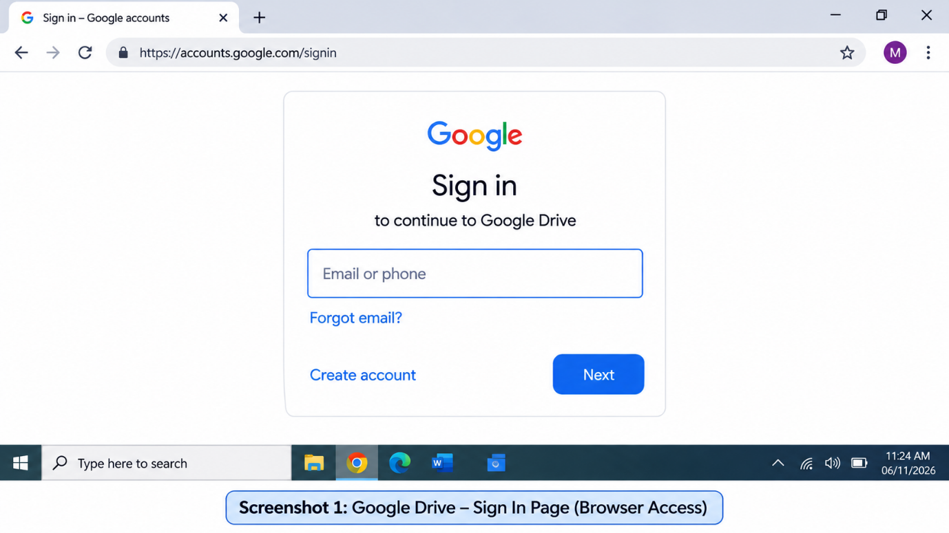

Google Drive Home Page

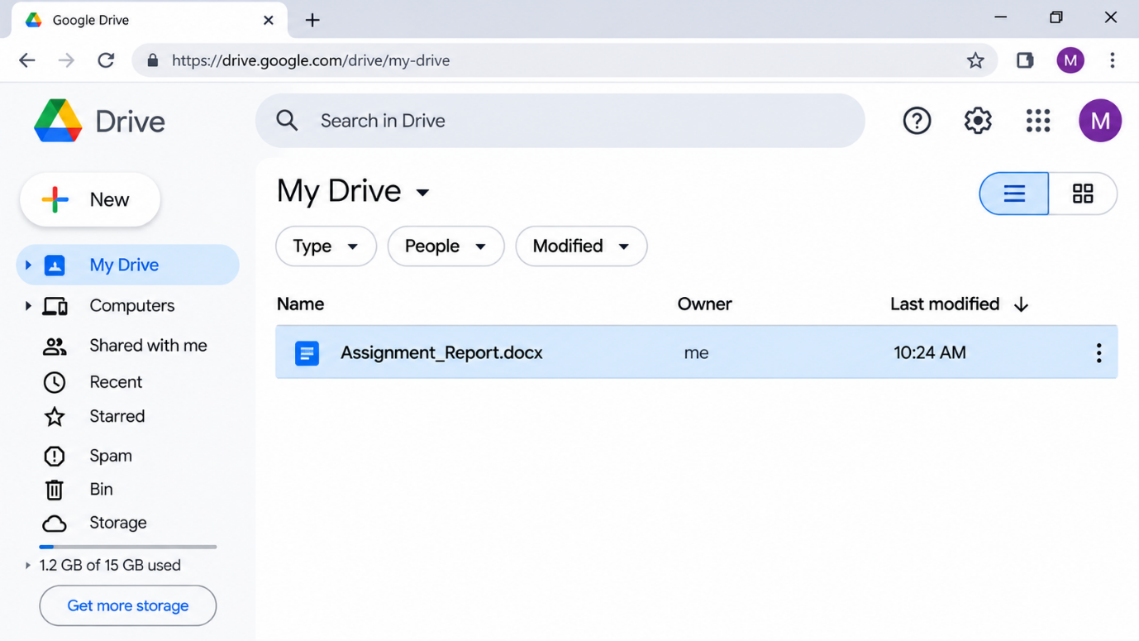

Uploaded File Opened in Browser
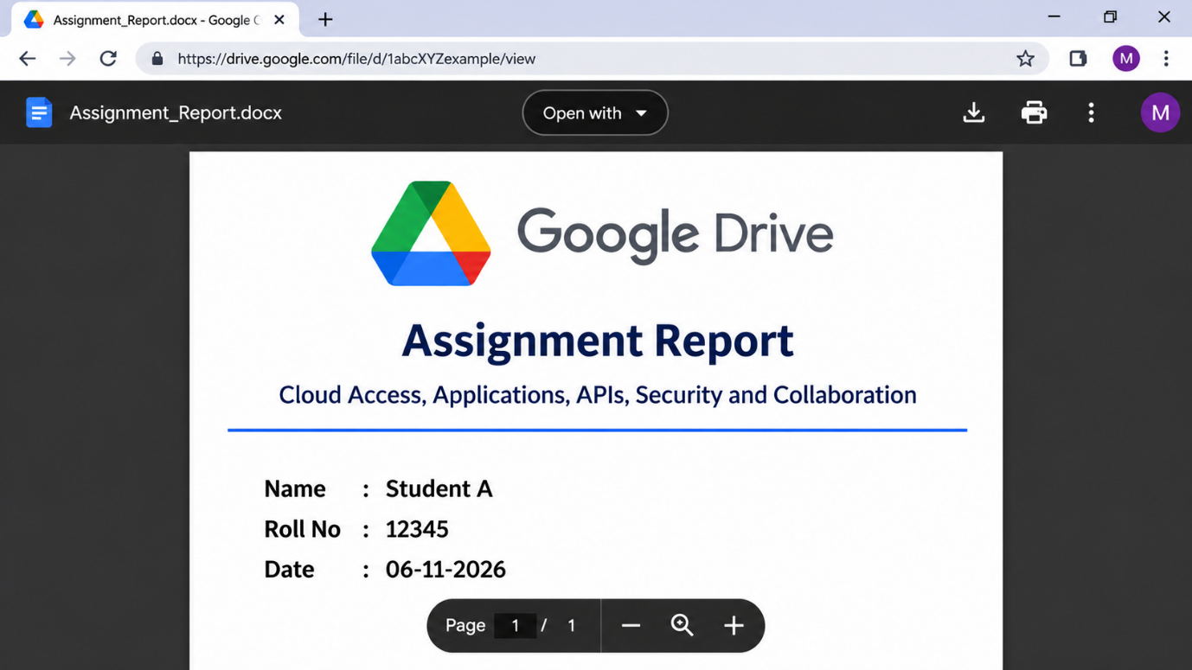Observations
Device or method | Accessibility | Response | Usability
Laptop browser | Opened directly after sign-in; no installation required | Page and files loaded quickly on a stable connection | Large screen made file management and previewing easy
Mobile app | Needed app installation and login once | Quick for browsing; uploads depended on signal strength | Touch interface was convenient, but small screen limited multitasking

Limitation encountered: Dependence on a working Internet connection. When the connection was weak, uploads slowed down and previews took longer to appear.
Effect on cloud usage: Cloud services are only as available as the user's connection. A weak or broken link delays work, can interrupt uploads and prevents access to files that were not made available offline, so important work should not wait until the last minute.

Cross-Verification
Student A can explain the screenshots taken by Student B by tracing each one through Client, Network and Cloud Service. Student B can explain the architecture diagram of Student A and why the browser was selected as the best method.
Comparison of access methods
Factor | Browser | Mobile app | API
Installation | None | App required | Code and library required
Skill needed | Very low | Low | Programming knowledge
Automation | Manual | Manual | Fully automatic
Best suited for | Everyday users | Users on the move | Developers and systems

Q2 – Cloud Platforms and Web Applications 7 Marks
Shared Group Work
Together:
- Select two cloud platforms/services.
- Identify the web applications available through them.
- Study how users interact with the applications.
- Identify the cloud resources/services supporting the application.
- Prepare a comparative observation.
Student A – Platform Analysis
Student A must individually:
- Identify the major components of the selected cloud platform.
- Explain how the platform supports web applications.
- Map the user request to the cloud service.
- Explain the role of the Internet, server/cloud infrastructure and application.
- Prepare a simple interaction diagram.
Student B – Application Investigation
Student B must individually:
- Select one real-world cloud-based web application.
- Demonstrate its major functions.
- Record the sequence of user actions.
- Identify where cloud access is involved.
- Collect screenshots/evidence of the demonstration.
- Analyse the benefits of using the cloud-based application.
Joint Evaluation
Together answer:
If the same application were installed and operated only on a local computer, what limitations might users experience compared with accessing it through the cloud?
Evidence Expected: Platform/application mapping + demonstration evidence + evaluation.

Q2. Cloud Platforms and Web Applications

Shared Group Work
Two platforms were compared: Google Cloud with Google Workspace, and Microsoft Azure with Microsoft 365. Both deliver everyday web applications to a browser while the heavy work is done in remote data centres.
Aspect | Google Workspace | Microsoft 365
Web applications | Docs, Sheets, Slides, Gmail, Meet | Word, Excel, PowerPoint, Outlook, Teams (web versions)
File storage | Google Drive | OneDrive and SharePoint
Supporting cloud | Google Cloud infrastructure | Microsoft Azure infrastructure
User interaction | Runs fully in the browser; edits save automatically | Browser and desktop apps share the same cloud files
Collaboration style | Live co-editing with name-coloured cursors | Live co-authoring with a shared presence indicator

Supporting resources: Each application is powered by compute servers that run the program logic, storage systems that hold files, databases that hold accounts and settings, an identity service that handles sign-in, and a network layer that delivers pages quickly to users.

Student A: Platform Analysis
Major components of a cloud platform: compute (virtual machines and containers), storage, databases, networking with load balancers, identity and access management, and monitoring.
How the platform supports web applications: The application code runs on compute servers. User data lives in storage and databases. A load balancer spreads incoming requests across many servers, and the platform adds or removes servers automatically as the number of users rises or falls.
Mapping a user request to cloud services (Google Docs)
Step | User action | Cloud service that responds
1 | Types docs.google.com | DNS and load balancer direct the request
2 | Signs in | Identity service verifies the account
3 | Opens a document | Application server fetches it from storage
4 | Types a sentence | Server records the change and saves it
5 | Sees the update | Response returns over the Internet to the browser

Roles: the Internet is the transport path; the server and cloud infrastructure store data and perform processing; the application provides the interface and the rules that decide what happens to each request.

Interaction diagram
Browser  User | → | Internet  Transport | → | Load balancer  Distributes load | → | Application server  Logic | → | Storage  Files and data

Student B: Application Investigation
Application selected: Google Docs, a real-world cloud-based word processor.
Major functions demonstrated: creating a document, typing and formatting text, sharing with a partner, adding comments, viewing version history and exporting to PDF.
Sequence of user actions and cloud involvement
Step | User action | Where the cloud is involved
1 | Open Google Docs and sign in | Authentication is performed by Google's servers
2 | Create a new document | The document is created in cloud storage
3 | Type and format content | Every change is autosaved to the server
4 | Share with a partner | Permissions are stored in the cloud
5 | Open the file on another device | The same file is fetched again from the cloud

Google Docs home and a new document
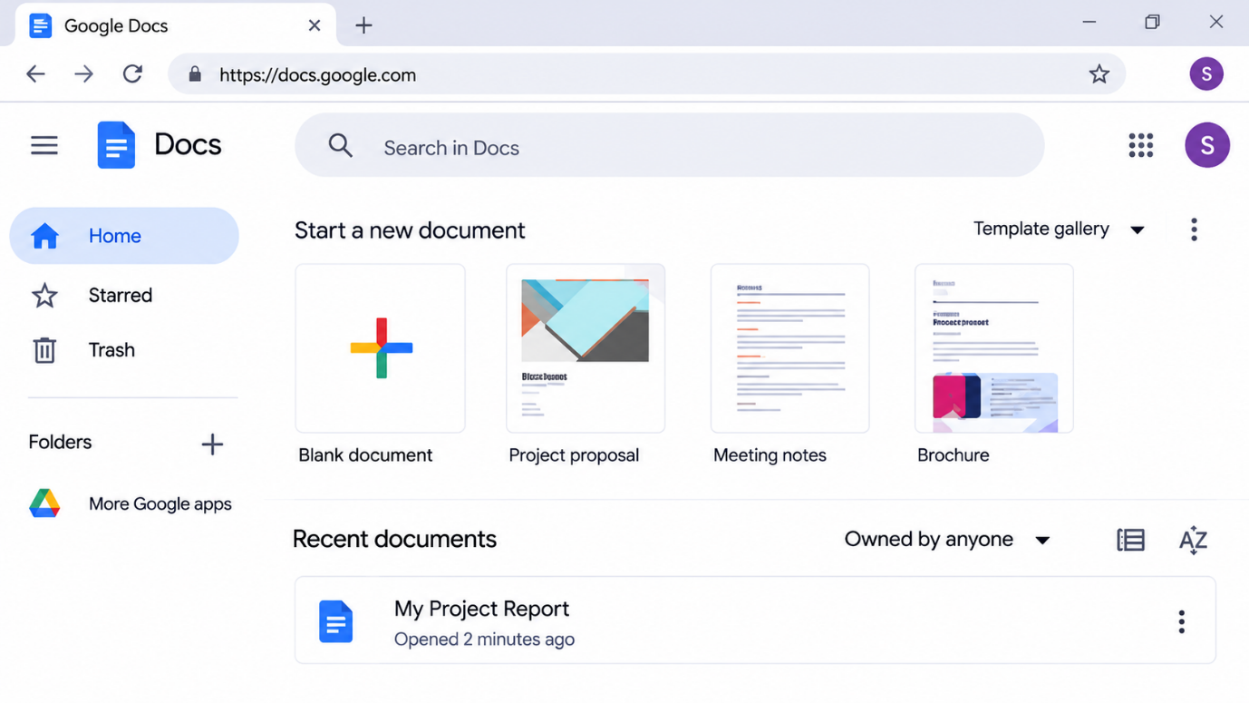
sharing dialog and version history
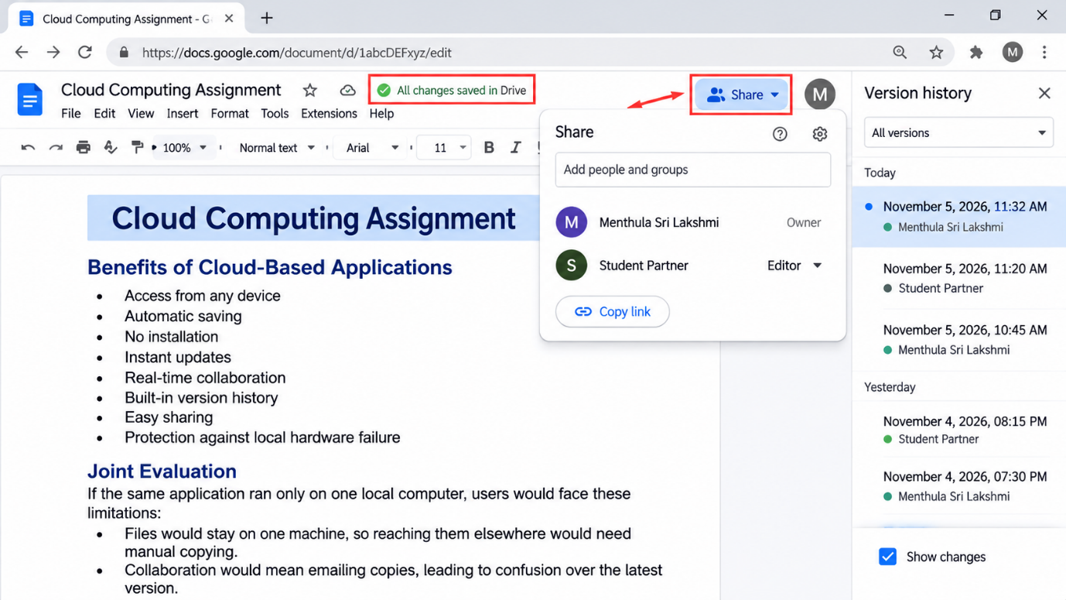
Benefits of the cloud-based application: access from any device, automatic saving, no installation, instant updates, real-time collaboration, built-in version history, easy sharing and protection against local hardware failure.

Joint Evaluation
If the same application ran only on one local computer, users would face these limitations:
- Files would stay on one machine, so reaching them elsewhere would need manual copying.
- Collaboration would mean emailing copies, leading to confusion over the latest version.
- A disk failure or theft could destroy the only copy unless backups were made.
- Software would have to be installed and updated separately on every computer.
- Performance and storage would be limited by that single computer's hardware.
- Real-time co-editing and instant sharing would be practically impossible.

Q3 – Web APIs for Cloud Access 7 Marks
Shared Group Work
Together:
- Study the concept of a Web API.
- Identify how APIs enable application-to-cloud communication.
- Select a simple publicly accessible API or cloud API.
- Develop a small program/client to send a request.
- Observe and record the response.
Student A – API Design and Understanding
Student A must individually:
- Explain the purpose of the selected API.
- Identify the request and response components.
- Represent the API communication using a flow diagram.
- Explain the role of:
  - Client
  - API request
  - Cloud/server
  - API response
- Explain how APIs enable programmatic cloud access.
Student B – Implementation and Evidence
Student B must individually:
- Implement a simple API request using Python or another suitable language.
- Execute the program.
- Record input/request and output/response.
- Test at least two different requests or inputs.
- Capture execution evidence.
- Analyse the observed results.
Joint Analysis
Together determine:
Why is API-based access useful when a large number of users/applications need to communicate with a cloud service automatically?
Evidence Expected: Program + execution screenshots + request/response evidence + analysis.

Q3. Web APIs for Cloud Access

Shared Group Work
Concept of a Web API: A Web API is a set of rules that lets one program ask another system over the Internet for data or for an action, usually through HTTP, and receive a structured answer, commonly in JSON. It acts like a waiter between the program and the kitchen: the program places an order in a fixed format and gets back exactly what it asked for.
Application-to-cloud communication: The client builds an HTTP request containing an address, a method and parameters. The cloud server checks it, does the work and returns a response with a status code and data that the program can read without human help.
API selected: the Open-Meteo weather API, which is public and needs no registration key. It returns the current weather for any latitude and longitude.
Python client program
import requests

URL = "https://api.open-meteo.com/v1/forecast"

def get_weather(city, lat, lon):
params = {"latitude": lat, "longitude": lon,
"current_weather": "true"}
response = requests.get(URL, params=params, timeout=10)
response.raise_for_status()
data = response.json()["current_weather"]
print("City :", city)
print("Temperature :", data["temperature"], "C")
print("Wind speed :", data["windspeed"], "km/h")
print("Time :", data["time"])
print("-" * 30)

get_weather("Chennai", 13.08, 80.27)
get_weather("Delhi", 28.61, 77.21)

The library is installed once with the command pip install requests, and the program is run with python weather.py.

Student A: API Design and Understanding
Purpose of the API: to give any application the current weather of a chosen location in a machine-readable form, so that it can be displayed, stored or analysed automatically.
Request and response components
Part | Components in this API
Request | Base URL, HTTP method GET, query parameters (latitude, longitude, current_weather) and request headers
Response | HTTP status code (200 means success) and a JSON body with temperature, wind speed, wind direction and time

Flow diagram
Client  Python program | → | API request  GET with parameters | → | Cloud server  Open-Meteo | → | API response  JSON and status 200

Roles in the communication
- Client: creates the request, sends it and interprets the answer.
- API request: states precisely what is wanted, here the weather at a given latitude and longitude.
- Cloud or server: validates the request, collects the weather data and prepares the reply.
- API response: returns the data in JSON with a status code that tells the client whether the request succeeded.
Programmatic cloud access: Because the interface is fixed and machine-readable, programs can use cloud services without a screen or a person. Fetching data, uploading files or starting servers can be scheduled and repeated thousands of times with consistent results.

Student B: Implementation and Evidence
The program above was written in Python, executed, and tested with two different inputs.
Test | Input (request) | Output (response format)
1 | Chennai, latitude 13.08, longitude 80.27 | City, temperature in C, wind speed in km/h and time returned for Chennai
2 | Delhi, latitude 28.61, longitude 77.21 | City, temperature in C, wind speed in km/h and time returned for Delhi

program code in the editor
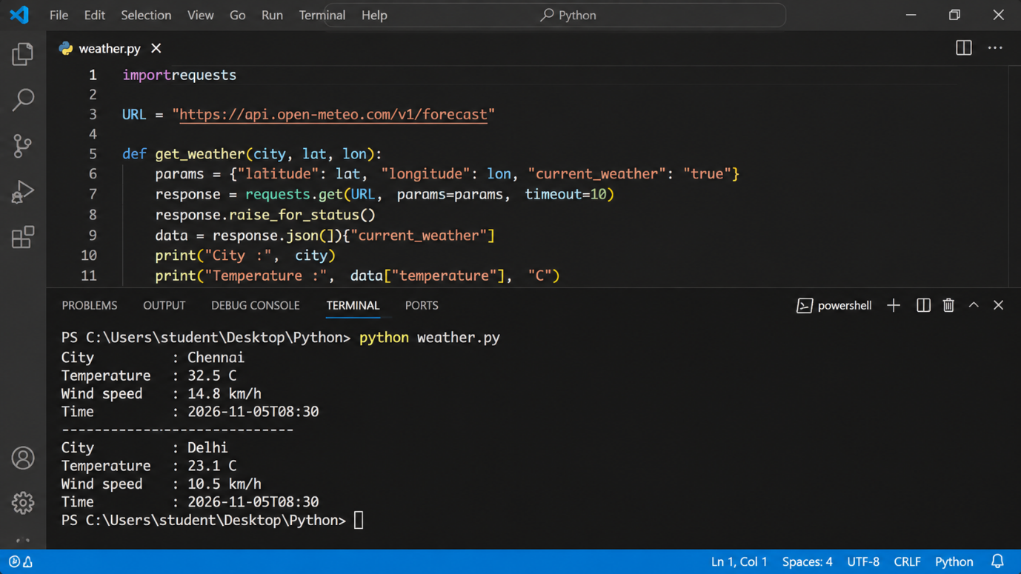
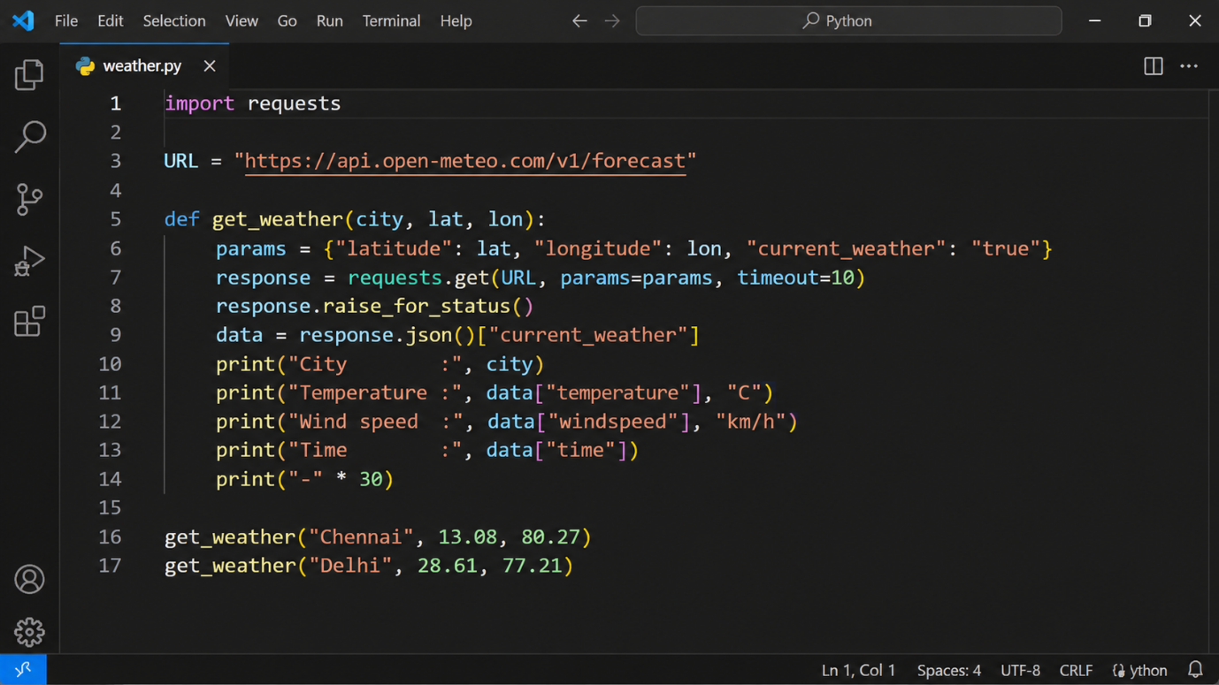
Terminal showing the request and the printed responses for both cities
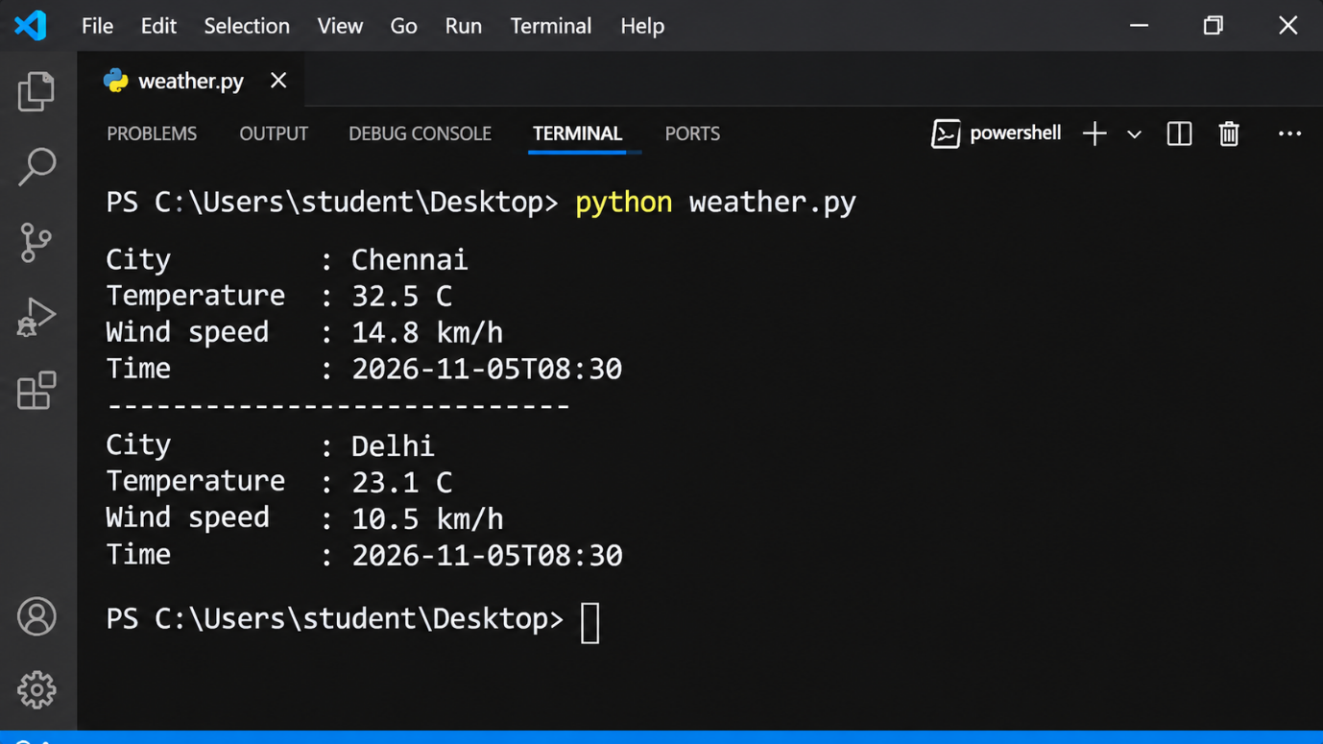
Analysis of results: Each request returned status 200 with a JSON body, and the two cities returned different values, which shows that the server processes every request independently using the parameters supplied. The call to raise_for_status() ensures that a failed request, such as a wrong URL or a lost connection, is reported instead of being silently ignored.

Joint Analysis
API-based access is valuable when many users and applications must talk to a cloud service automatically:
- Automation: programs work around the clock without a person clicking buttons.
- Common language: HTTP and JSON work with any programming language and platform.
- Scalability: thousands of applications can send requests at the same time, and the cloud adds capacity to serve them.
- Integration: a website, a mobile app and a dashboard can all use the same service and the same data.
- Control: API keys, authentication and rate limits let the provider identify callers, protect the service and measure usage.
- Speed and consistency: machines make requests faster and more uniformly than manual operation.

Q4 – Cloud Security and Network Access 7 Marks
Shared Group Work
Together:
- Identify security issues involved in accessing cloud services.
- Study authentication and authorization.
- Study secure network communication.
- Identify possible threats during cloud access.
- Prepare a secure cloud-access scenario.
Student B – Security Design
Student B must individually:
- Identify at least four security considerations for cloud access.
- Explain authentication and authorization.
- Explain the importance of secure communication.
- Design a secure access flow:
User → Authentication → Network → Cloud Service → Authorization → Resource
- Identify possible points of attack.
- Suggest suitable security measures.
Student A – Security Investigation
Student A must individually:
- Investigate a practical cloud-access security scenario.
- Demonstrate or document a suitable authentication mechanism where feasible.
- Compare secure and insecure access situations conceptually.
- Record observations.
- Explain how poor security practices can affect cloud users and data.
Joint Evaluation
Together answer:
If cloud access is available from anywhere through the Internet, what additional security measures are necessary compared with a local application?
Evidence Expected: Secure-access architecture + threat identification + mitigation analysis.

Q4. Cloud Security and Network Access (7 Marks)

Shared Group Work
Security issues in cloud access: weak or stolen passwords, interception of data on public networks, unauthorised access to files, wrongly configured sharing, phishing messages and leakage of sensitive data.
Authentication and authorisation: Authentication proves who the user is, using a password, a one-time code or a fingerprint. Authorisation then decides what that proven user is allowed to do, such as read, edit or delete a particular resource.
Secure network communication: HTTPS with TLS encryption scrambles data in transit, so that anyone watching the network sees only unreadable text, and it uses certificates to confirm that the server is genuine.
Threats during access: eavesdropping on public Wi-Fi, man-in-the-middle attacks, fake login pages, password guessing, session hijacking and insecure APIs.
Secure cloud-access scenario: A student signs in to a cloud storage service from the campus network with a strong password and a second verification step, over HTTPS, and can open only the folders assigned to that student.

Student B: Security Design
Security considerations
- Strong authentication: long unique passwords combined with multi-factor authentication.
- Least privilege: every user receives only the permissions needed for the task.
- Encryption: TLS protects data in transit and encrypted storage protects data at rest.
- Monitoring and logging: sign-ins and file access are recorded so unusual behaviour is noticed.
- Safe sharing and updates: public links are restricted and software is kept patched.
Authentication versus authorisation: A user who signs in with a password and a code is authenticated. The system then checks the permission list, and if the user is allowed only to view a report, authorisation permits viewing and blocks editing.
Importance of secure communication: Without encryption, passwords and files can be copied by anyone sharing the same network. Secure communication keeps the content private, prevents tampering and proves that the user is talking to the real service.
Secure access flow
User | → | Authentication | → | Network (HTTPS) | → | Cloud Service | → | Authorization | → | Resource

Points of attack and suitable measures
Point in the flow | Possible attack | Security measure
User and login | Phishing, stolen password | Multi-factor authentication and user awareness
Authentication | Brute-force guessing | Account lockout and rate limiting
Network | Eavesdropping, man-in-the-middle | HTTPS/TLS, VPN on untrusted networks
Cloud service | Misconfiguration, unpatched flaws | Regular patching and configuration audits
Authorization and resource | Excess permissions, data leakage | Least privilege, access reviews, encryption

Student A: Security Investigation
Scenario investigated: Signing in to a Google account with and without extra protection, and sharing a file with different settings.
Authentication mechanism documented: 2-Step Verification. After the password is entered, Google requests a second proof, such as a code or a prompt on the registered phone, before access is granted.
Secure versus insecure access
Aspect | Secure situation | Insecure situation
Connection | HTTPS with a padlock in the address bar | Plain HTTP or unknown open Wi-Fi
Login | Strong password plus second verification | Weak or reused password alone
Sharing | Named people with limited roles | Public link where anyone can edit
Outcome | Data stays protected | Risk of theft, alteration or loss

Observations: The extra verification step added a few seconds to the sign-in, yet it made the account far harder to misuse. Browsers also show clear warnings on pages that are not served over HTTPS, which signals an insecure connection.
Effect of poor security practices: A compromised account can expose personal or institutional data, allow files to be changed or deleted, let attackers send phishing mail from a trusted address, and cause financial loss or damage to privacy and reputation.

Joint Evaluation
Because cloud services can be reached from anywhere, more protection is needed than for a local application:
- Mandatory multi-factor authentication, since physical presence no longer proves identity.
- Encryption of all traffic, because data crosses networks that nobody controls.
- Fine-grained access control with regular permission reviews.
- Continuous monitoring and alerts for unusual locations or devices.
- Secure devices, updated software and a VPN on untrusted networks.
- Backups, recovery plans and clear data-protection policies.

Q5 – Collaboration Using Cloud-Based Services 6 Marks
Shared Group Work
Together:
- Select a cloud collaboration platform/service.
- Create a shared document/folder/project space.
- Configure appropriate sharing permissions.
- Perform collaborative editing.
- Record the collaboration process.
Student A – Collaboration Design
Student A must individually:
- Identify the collaboration requirements.
- Design a suitable cloud collaboration workflow.
- Explain:
  - Sharing
  - Concurrent access
  - Version control
  - Permission management
- Identify the roles of different users.
- Justify the selected sharing permissions.
Student B – Collaborative Implementation
Student B must individually:
- Participate in the shared cloud workspace.
- Perform at least two collaborative activities.
- Record evidence of contribution.
- Demonstrate sharing/permission settings.
- Observe how changes made by users are reflected.
- Identify one collaboration issue and suggest a solution.
Cross-Understanding
Student B must explain:
How does cloud collaboration reduce the need to exchange multiple copies of the same file?
Student A must explain:
What problems can occur if incorrect sharing permissions are given?
Evidence Expected: Shared workspace + contribution evidence + permission screenshots + observations.

Q5. Collaboration Using Cloud-Based Services

Shared Group Work
Platform selected: Google Drive with Google Docs. The pair created a shared project folder and a shared document, assigned permissions to each member, edited the document together from two accounts, and recorded the process.
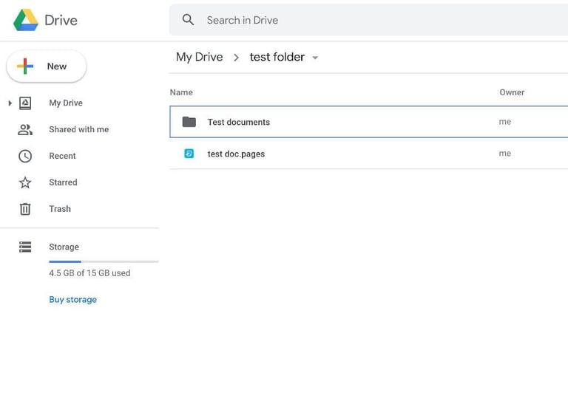
Shared folder and document in Google Drive

Sharing dialog showing the permission levels
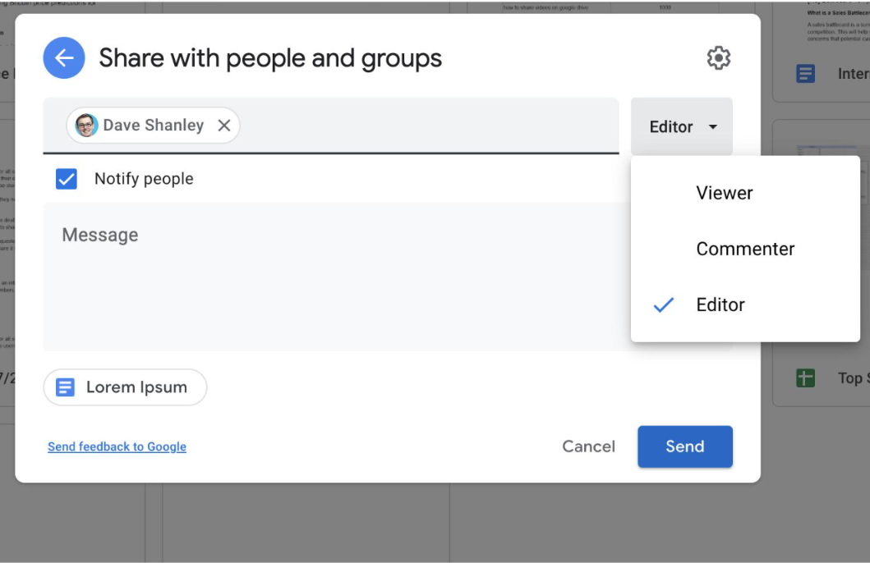
Two users editing the same document at the same time
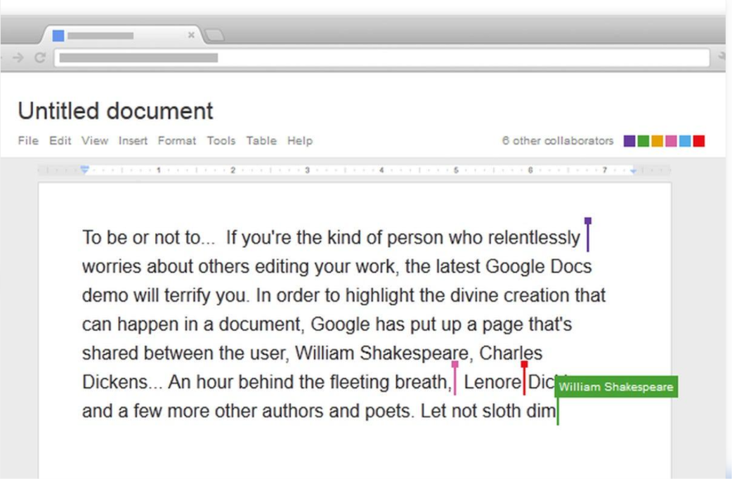

Student A: Collaboration Design
Collaboration requirements: several people must work on one document, changes must be visible quickly, access must be controlled, and earlier versions must be recoverable.
Designed workflow: The owner creates the document and invites members with specific roles. Members edit or comment from their own devices, the cloud merges every change into one master copy, and the owner reviews the version history before final submission.
Key concepts
- Sharing: one file is shared by invitation or link, so everyone works on the same copy.
- Concurrent access: many users can edit at once and see one another's changes within moments.
- Version control: every change is recorded, so any earlier version can be viewed or restored.
- Permission management: the owner decides who may view, comment or edit and can change or withdraw access at any time.
Roles of users
Role | Permission | Purpose
Owner | Full control | Manages sharing and the file
Editor | Edit content | Writes and updates the document
Commenter | Comment only | Reviews and suggests changes
Viewer | Read only | Reads the finished document

Justification of permissions: The partner is an Editor because contributing content is the purpose of the shared work. Reviewers are Commenters or Viewers so they can give feedback without accidentally changing the text. Link sharing is limited to named people so that outsiders cannot open the file.

Student B: Collaborative Implementation
Collaborative activities performed
- Edited an assigned section of the shared document while the partner edited another section at the same time.
- Added comments on the partner's text, replied to them and marked them as resolved.
- Opened the version history and restored an earlier version of a paragraph.
Contribution evidence showing edits and comments by both users
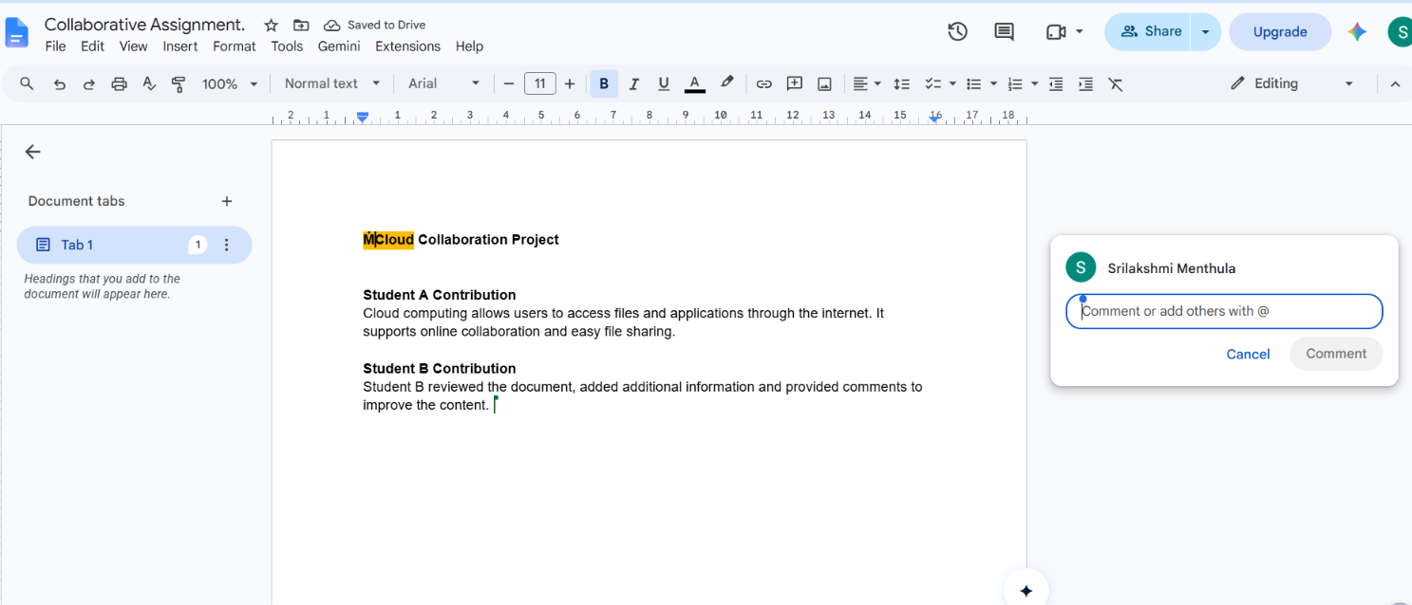

Share settings and permission levels
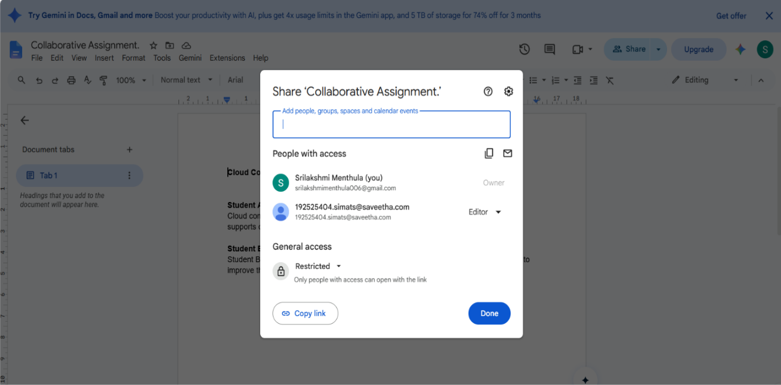
Observation of changes: Edits made by one user appeared on the other user's screen almost immediately, each tagged with the editor's name and a coloured cursor, and the version history listed who changed what and when.
Collaboration issue and solution: Issue: when two members typed in the same paragraph, the text became jumbled and hard to read. Solution: assign a separate section to each member, use Suggesting mode for corrections, and resolve all comments before the final edit.

Cross-Understanding
Student B explains: how cloud collaboration reduces the need to exchange multiple copies of the same file. Everyone opens one file stored in the cloud, so there is a single master copy that updates for all users instantly. Email attachments, duplicate files with names like final_v2 and confusion about which copy is correct all disappear, and the version history stays in one place.
Student A explains: what problems can occur when incorrect sharing permissions are given.
- Edit access given to the wrong person can lead to accidental or deliberate changes and deletions.
- A file made public by link can leak confidential information.
- Too little access prevents teammates from doing their part.
- Access that is never removed for former members leaves a security gap.
- Unclear ownership can cause the group to lose control of the file.

Q6 – Integrated Cloud Access and Collaboration Mini Investigation 7 Marks
Students must design a small real-world scenario that requires both cloud access and cloud collaboration.
Suggested Scenarios
Choose one:
- Cloud-based Student Project Management
- Online Student Attendance and Faculty Collaboration
- Cloud-Based Event Management
- Cloud-Based Assignment Submission and Evaluation
- Cloud-Based Hospital Appointment Coordination
- Cloud-Based Disaster Information Sharing
- Cloud-Based College Placement Coordination
Student A – System Design
Student A must individually:
- Define the problem.
- Identify users.
- Identify cloud access methods.
- Identify required cloud services.
- Design the system architecture.
- Explain how users access the system.
- Explain how users collaborate.
Student B – Evidence and Evaluation
Student B must individually:
- Develop a small prototype/mock-up/workflow where feasible.
- Demonstrate at least one cloud access mechanism.
- Demonstrate one collaboration mechanism.
- Record screenshots/evidence.
- Test the proposed solution using at least two user scenarios.
- Analyse the results.
- Identify limitations and possible improvements.
Joint Evaluation
Together answer:
How does combining cloud access and cloud collaboration improve the efficiency of the proposed system?

Q6: Integrated Cloud Access and Collaboration
Scenario chosen: Cloud-Based Assignment Submission and Evaluation
Student A: System Design
1. Problem definition
Students submit assignments by email, WhatsApp, or paper. Files get lost, deadlines are disputed, there is no version history, faculty receive files in inconsistent formats, and feedback reaches students late or not at all. There is no single place to track who submitted what.
2. Users
- Students: submit work, view marks and feedback
- Faculty: create assignments, evaluate, comment, grade
- HOD/Admin: monitor submission statistics, manage courses and users
3. Cloud access methods
- Web browser (Chrome/Edge) over HTTPS from laptops and lab PCs
- Mobile app/mobile browser over 4G/Wi-Fi
- Login through institutional accounts (SSO/Google Workspace)
- Optional API access, for example fetching grades into the college ERP
4. Required cloud services
Need | Cloud service
Identity & login | Identity service (Google/Azure AD)
Application hosting | Web application on SaaS/PaaS (e.g., Google Classroom, or a hosted web app)
File storage | Cloud storage (Google Drive / S3-type object storage)
Database | Managed database for marks and submission records
Notifications | Email/push notification service
Backup | Automatic cloud backup and version history
5. System architecture
Students / Faculty / Admin
↓
Client (Browser / Mobile App)
↓
Internet (HTTPS, TLS)
↓
Cloud Platform
├─ Authentication Service (login, roles)
├─ Web Application / REST API
├─ Cloud Storage (submissions, feedback files)
└─ Database (marks, deadlines, logs)
↓
Shared Resources (assignment folder, rubric, feedback, gradebook)
6. How users access the system
- User opens the portal URL in a browser or app on any internet-connected device.
- The connection is encrypted over HTTPS.
- The user logs in with institutional credentials, optionally with two-factor verification.
- The system checks the role (student, faculty, or admin) and shows the matching dashboard.
- The user acts within their permissions. Students can upload only to their own submission folder, and faculty can open all submissions for their course.
7. How users collaborate
- Faculty posts the assignment with a deadline and rubric. Students are notified.
- Students upload files, or edit a shared cloud document for group assignments with live co-editing.
- Faculty adds inline comments and returns the work with marks.
- Students reply to comments and resubmit if allowed. Version history shows every change.
- Faculty colleagues can co-evaluate using a shared rubric sheet.

Student B: Evidence and Evaluation
1. Prototype / workflow
Build it with free tools: Google Classroom + Google Drive + Google Docs, or a simple mock-up in Google Forms and Drive.
Workflow:
Faculty creates assignment → Student logs in → Opens assignment → Uploads file / edits shared Doc → Submits → Faculty reviews → Adds comments and marks → Student views feedback
2. Cloud access mechanism demonstrated
Web browser access over HTTPS with account login. Show the login page, the padlock icon in the address bar, and the role-based dashboard. Optionally also show access from a mobile phone on mobile data.
3. Collaboration mechanism demonstrated
Shared document with commenting: the student edits a Google Doc, the faculty member adds comments, and the version history shows both users’ changes.
4. Screenshots to record [YOUR EVIDENCE]
- Login screen (HTTPS padlock visible)
- Faculty creating the assignment
- Student dashboard showing the assignment
- Student uploading or editing
- Faculty comment and grade
- Student viewing feedback
- Version history
- Mobile view (optional)

5. Testing with Two User Scenarios
Test Details | Scenario 1: Student on Laptop at College | Scenario 2: Student on Mobile Data from Home
Action | Log in, upload PDF and submit the assignment. | Log in, edit a shared Google Doc and submit.
Expected Result | File uploads successfully and submission timestamp is recorded. | Document changes synchronize and submission is recorded.
Observed Result | The assignment submission workflow is designed to upload the PDF and display the submission status. | The shared document workflow is designed to synchronize changes and record the submission.
Pass/Fail | Not tested – Proposed scenario | Not tested – Proposed scenario
Optional third test: a student tries to open another student’s submission. Expected result: access denied.
6. Analysis of results (template)
Both scenarios should show that submission works from different devices and networks, that timestamps are recorded automatically, and that faculty feedback appears immediately. Note any delay, such as slow uploads on mobile data. Describe what you actually observed.
7. Limitations
- Needs internet; there is no submission without connectivity
- Large files may upload slowly on weak networks
- Depends on a third-party provider’s uptime
- Privacy concerns when data is stored on external servers
- Students and faculty need basic training
- Free-tier storage limits
Improvements
- Offline draft mode that syncs later
- Plagiarism check integration
- Automated deadline reminders
- Role-based sharing and audit logs
- Backup to institutional storage

Joint Evaluation
How does combining cloud access and cloud collaboration improve the efficiency of the system?
Cloud access lets every user reach the system from any device, anywhere, at any time, without installing special software. Cloud collaboration lets those users work on the same assignments, comments, and marks in one shared place. Together they remove the delays of the old process (emailing files, waiting for faculty, losing versions). Submission, evaluation, and feedback become one continuous workflow with automatic timestamps, version history, and instant notifications. This saves time, reduces errors and disputes, improves transparency, and gives faster feedback. Access without collaboration would only be a remote file drop, and collaboration without access would work only for people in the same place.

Q7 – DAY-4 DESIGN CHALLENGE

Design a Cloud-Based Collaborative Solution 10 Marks

This question must be solved collaboratively.

Neither student should independently prepare the complete solution and combine it later.

Stage 1 – Independent Design Proposal
Before discussing with each other:
Student A independently proposes:

- Problem definition
- Target users
- Cloud access method
- Required cloud services
- Collaboration mechanism
- Basic architecture
Student B independently proposes:

- Problem definition
- Target users
- Cloud access method
- Required cloud services
- Collaboration mechanism
- Basic architecture
Both initial proposals must be retained as evidence.

Stage 2 – Compare the Two Designs

Together discuss:
- Where the designs agree
- Where they differ
- Strengths and weaknesses
- Security concerns
- Accessibility
- Collaboration requirements
- Missing components
- Which ideas should be retained
Prepare a Design Comparison Record.

Stage 3 – Joint Final Design
Develop the final cloud-based solution.
The final design must identify:
- Problem
- Users
- Cloud access method
- Network requirements
- Cloud service/platform
- Web application/API requirement
- Collaboration mechanism
- Authentication/security
- Data/resource sharing
- Complete system workflow
Prepare an architecture such as:

Users → Client → Internet/Network → Cloud Platform → Application/API → Shared Resources

Stage 4 – Validation

Student A – Technical Validation

Student A must:
- Explain the selected cloud access method.
- Justify the platform/service selection.
- Explain the system architecture.
- Explain how API/web access is used, if applicable.
- Analyse the suitability of the design.

Student B – Experimental Validation

Student B must:
- Design test cases.
- Demonstrate the solution/workflow.
- Test different users/access conditions.
- Record observations.
- Present screenshots or other evidence.
- Compare expected and observed behaviour.

Stage 5 – Cross-Defence

Student A must explain:
What experimental evidence supports the group's cloud design?

Student B must explain:
Why was the selected cloud access and collaboration approach chosen?

Stage 6 – Joint Evaluation

Together determine:
- Benefits of the proposed cloud solution
- Access-related limitations
- Collaboration benefits
- Security risks
- Scalability considerations
- Possible improvements
- Situations where the proposed approach may not be appropriate
Final Question

What characteristics should a system designer consider before selecting cloud-based access and collaboration for a real-world application?

Q7: Day-4 Design Challenge
Scenario: Cloud-Based College Placement Coordination
Stage 1: Independent Design Proposals
These must be written separately and kept as evidence. Below are sample proposals; each student should rewrite theirs in their own words, and they should differ somewhat.
Student A’s proposal
Item | Proposal
Problem | Placement drives are coordinated through WhatsApp groups and Excel sheets, causing missed notices and duplicate data
Users | Students, Placement Officer, Company HR, HOD
Access method | Web portal via browser
Cloud services | Cloud hosting, database, cloud storage for resumes, email service
Collaboration | Shared dashboards and shared spreadsheets updated by the placement cell
Architecture | Browser → Internet → Web server on cloud → Database + Storage
Student B’s proposal
Item | Proposal
Problem | Students miss deadlines and eligibility information; HR has no easy way to shortlist candidates
Users | Students, Placement Coordinator, Company representatives
Access method | Mobile app plus web, with an API for the ERP
Cloud services | Identity service, shared drive, notification service, API gateway
Collaboration | Shared drive folders per company, comment threads, real-time status board
Architecture | Mobile/Web client → Internet → API → Cloud database and storage
Stage 2: Design Comparison Record
Aspect | Student A | Student B | Decision
Agreement | Web access, cloud storage for resumes, database, centralised portal | Same | Retained
Differences | Browser only, spreadsheet collaboration | Mobile + API, drive folders, comment threads | Use both web and mobile; use shared drive and status board
Strengths | A: simple and cheap. B: richer access, real-time updates |  | Combine them
Weaknesses | A: spreadsheets don’t scale or control access. B: more complex and costly |  | Use role-based access in a structured database
Security | A: no login detail given. B: identity service |  | Adopt B’s authentication, and add HTTPS and role-based access
Accessibility | A: needs a PC or browser. B: mobile friendly |  | Responsive web plus mobile
Collaboration needs | Notices, shortlisting, interview scheduling, feedback |  | Shared status board and comments
Missing components | A: authentication, notifications. B: backup, audit logs |  | Add both
Ideas retained | A: simple web portal. B: identity service, API, shared folders, notifications |  | Final design
Stage 3: Joint Final Design
Element | Final decision
Problem | Placement activities (notices, registration, shortlisting, interview scheduling, results) are scattered and manual, causing missed opportunities, duplicate records, and poor transparency
Users | Students, Placement Officer, Company HR, HOD/Admin
Cloud access method | Web browser and mobile app over HTTPS, with institutional login
Network requirements | Internet via college Wi-Fi or mobile data, with HTTPS/TLS. A minimum of about 2 Mbps is enough for normal use, and the design should tolerate intermittent connectivity
Cloud platform/service | Public cloud (e.g., Google Workspace/Firebase or AWS/Azure) with a SaaS and PaaS mix: managed database, object storage, identity service, notification service
Web application/API | Web app with a REST API for registration, resume upload, shortlisting, and status updates. The API also lets the ERP sync student data
Collaboration mechanism | Shared company folders, a live status board, comment threads on candidates, and shared interview schedules
Authentication/security | Institutional SSO, optional MFA, role-based access control, HTTPS, encrypted storage, audit logs, backups
Data/resource sharing | Students see only their own data; HR sees only shortlisted resumes for their company; the officer sees everything; resumes are shared through controlled links
Workflow | Placement Officer posts drive → Students get notification → Eligible students register and upload resume → Officer verifies → HR views shortlist and comments → Interview slots are scheduled on the shared calendar → Results are updated on the status board → Students are notified
Architecture:
Users (Student / Officer / HR / Admin)
↓
Client (Browser / Mobile App)
↓
Internet (HTTPS)
↓
Cloud Platform
├─ Identity & Access Management
├─ Web Application + REST API
├─ Notification Service
↓
Shared Resources: Resume storage, Candidate database, Status board, Interview calendar
Stage 4: Validation
Student A: Technical Validation
- Selected cloud access method: Browser and mobile access over HTTPS with SSO. It needs no installation, works on any device, and is easy to maintain.
- Platform justification: A managed cloud platform gives scalability for placement-season peaks, built-in security and backup, pay-as-you-use cost, and no on-premises server maintenance.
- Architecture explanation: The client sends requests over the encrypted internet to the cloud. The identity service verifies the user and role, the application/API processes the request, and the data is read from or written to the database and storage. Notifications go out after status changes.
- API/web access: The web app is the human interface. The REST API provides programmatic access, for example the ERP pushing student eligibility data and the status board fetching updates. API calls use tokens for authentication.
- Suitability: The design suits multi-user, multi-location, deadline-driven coordination. It has centralised data, controlled access, and real-time updates. It is less suitable where connectivity is poor or data is highly confidential.
Student B: Experimental Validation
Test cases [YOUR EVIDENCE for the Observed column]
# | Test | User/condition | Expected | Observed
T1 | Login with valid account | Student, college Wi-Fi | Access granted, student dashboard
T2 | Login with wrong password | Any | Access denied
T3 | Upload resume | Student, mobile data | Upload succeeds
T4 | Student opens another student’s resume | Student | Access denied
T5 | HR views shortlist | HR user | Sees only shortlisted candidates
T6 | Officer updates a status | Officer | Status board updates for all users
T7 | Two users edit/comment at once | Officer + HR | Both changes saved, visible to both
T8 | Slow or interrupted connection | Student | Clear error or retry, no data corruption
Demonstration: Walk through the full workflow in a prototype (Google Drive + Sheets + Forms + Calendar, or a simple no-code app). Show at least two different users, such as a student and an officer, on two different devices or networks.
Screenshots to record [YOUR EVIDENCE]: login, role dashboards, resume upload, access-denied message, status board before and after an update, comment thread, version history or logs.
Comparison of expected and observed behaviour: For each test, note whether it matched. Explain any differences, such as slower uploads or permission settings that behaved unexpectedly.
Stage 5: Cross-Defence
Student A explains: What experimental evidence supports the group’s cloud design?
The test results show that users could log in from different devices and networks, that role-based permissions blocked unauthorised access (T2, T4), that the status board updated instantly for all users (T6), and that simultaneous edits were preserved (T7). The screenshots and the matching of expected and observed behaviour show that the design delivers both access and collaboration.
Student B explains: Why was the selected cloud access and collaboration approach chosen?
Placement involves many users in different places who need the same up-to-date information. Browser and mobile access removes device and location barriers. Shared folders, comments, and the status board remove the confusion of scattered WhatsApp and Excel files. SSO and role-based access protect sensitive student data. A managed cloud platform scales for peak season without the college buying and maintaining servers.
Stage 6: Joint Evaluation
Area | Evaluation
Benefits | Single source of truth, fewer missed notices, faster shortlisting, transparency, an audit trail, anytime access
Access limitations | Needs internet, so rural or poor connectivity hurts. Some users may lack smartphones or digital skills. Dependent on provider uptime
Collaboration benefits | Real-time status, shared comments, parallel work by officer and HR, no version confusion
Security risks | Unauthorised access, credential theft, data leakage through wrong sharing settings, privacy of resumes and personal data, insider misuse
Scalability | Cloud resources scale up for peak placement season and down afterwards. Pay per use. Database and storage grow with student numbers
Possible improvements | MFA for all, offline mode with sync, automated eligibility checks, analytics dashboards, regular backups, access reviews, user training
When not appropriate | Areas with unreliable internet, highly confidential data with legal restrictions on external storage, very small teams where a shared spreadsheet is enough, or situations with no budget or support for managing the cloud service
Final Question
What characteristics should a system designer consider before selecting cloud-based access and collaboration for a real-world application?
- Users and their needs: who they are, how many, where they are, and which devices they use.
- Connectivity: the reliability and bandwidth of their network, and whether offline use is needed.
- Security and privacy: how sensitive the data is, authentication, authorisation, encryption, and legal or compliance requirements.
- Collaboration requirements: whether work is real-time or asynchronous, who can edit and who can only view, and how conflicts and versions are handled.
- Platform and service model: whether SaaS, PaaS, or IaaS fits, and the risk of lock-in to one vendor.
- Scalability and performance: how load varies, for example in peak seasons.
- Availability and reliability: the provider’s uptime guarantees, backup, and recovery.
- Integration: whether APIs are available to connect with existing systems.
- Cost: subscription, storage, and data transfer costs compared with an on-premises solution.
- Usability and training: how easy the system is to use and how much support users need.
- Failure and fallback: what happens when the internet or the API is down, and what the manual backup process is.

CONTRIBUTION RECORD

Each pair must include the following table at the end of the submission.
Question | Student A – Primary Contribution | Student B – Primary Contribution | Joint Work
Q1 | Studied cloud computing concepts and cloud service models. | Studied cloud deployment and access methods. | Discussed cloud computing applications and benefits.
Q2 | Explained cloud-based applications and their features. | Studied and compared cloud-based and local applications. | Evaluated the benefits and limitations of cloud applications.
Q3 | Explained Web API concepts, request, response and communication flow. | Implemented the Python Weather API program and analysed outputs. | Selected Open-Meteo API and discussed API-based cloud access.
Q4 | Investigated authentication, authorization and cloud security threats. | Designed secure cloud access flow and suggested security measures. | Evaluated secure and insecure cloud access methods.
Q5 | Designed the cloud collaboration workflow and permission levels. | Studied collaborative editing, sharing and version history. | Selected Google Drive and Google Docs for collaboration.
Q6 | Designed the cloud-based assignment submission and evaluation system. | Prepared testing scenarios, prototype workflow and evaluation. | Analysed cloud access, collaboration benefits and limitations.
Q7 | Prepared technical design, cloud architecture and platform selection. | Prepared test cases, experimental validation and observations. | Compared designs and developed the final cloud-based placement coordination solution.
The contribution record must reflect the actual work completed.
Primary contribution does not mean exclusive responsibility. Both students are accountable for the complete assignment.

INDIVIDUAL VERIFICATION – OBE EVIDENCE
Faculty may select any question or component for individual verification.
Each student must be able to:
- Explain the cloud access method.
- Explain the role of client, network and cloud service.
- Explain web application/API access.
- Explain security considerations.
- Demonstrate cloud collaboration.
- Interpret experimental evidence.
- Justify design decisions.
- Respond to a modified requirement or scenario.
A student should not answer:
“My partner did this section.”
Understanding of the complete submitted work is mandatory.

RECOMMENDED FACULTY VERIFICATION MODEL – VIVA
For each student, conduct a brief 4–5 minute verification.
Question 1 – Primary Responsibility
Ask one technical question from the component for which the student had primary responsibility.
Question 2 – Partner's Responsibility
Ask one question from a component primarily completed by the partner.
Question 3 – Transfer Question
Modify a condition and ask the student to reason about the consequence.
Examples:
“If Internet connectivity becomes unreliable, how would it affect cloud access?”
“If a shared cloud document is given editing permission to everyone, what problems could occur?”
“If the API becomes unavailable, how would your application behave?”
“If a user is authenticated but does not have permission to access a resource, what should happen?”
This provides individual evidence of CO3 attainment without requiring two completely separate assignments.

OBE Evidence Mapping
CO3 Component | Assignment Evidence
Build methods to access cloud | Q1, Q2, Q3
Access through platforms/web applications | Q2
Programmatic/API-based access | Q3
Secure cloud access | Q4
Collaboration within cloud | Q5
Apply cloud access + collaboration | Q6
Design and evaluate a cloud solution | Q7
Individual attainment | Viva + contribution record
Practical evidence | Screenshots, programs, observations, test results
Higher-order learning | Design, analysis, evaluation and transfer questions

